**Intelligent Mouse Trap**

Implementation

Our project idea is an Intelligent Mouse Trap. It uses a PIR sensor to detect the presence of living beings, i.e. a mouse in the trap. Our prototype is as shown below.

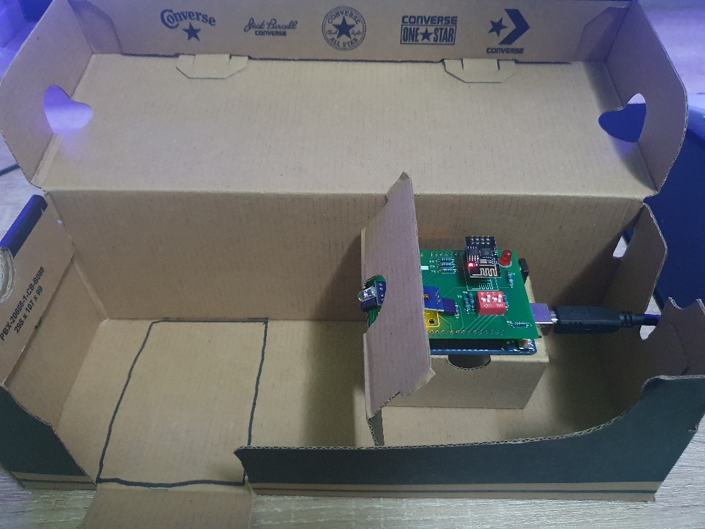

We used a shoebox to contain the trap as it is around the ideal size for it. The Arduino UNO board and shield is elevated to provide better detection. This is because we discovered that the PIR does not function as intended if it is positioned too close to the ground. There is a partition separating the PIR sensor from the glue board, to prevent the mouse from reaching the Arduino UNO.

After the mouse makes contact with the glue board, it will become stuck. Then, the PIR sensor will detect its presence and turn on the LED light on the Arduino UNO. The value of the PIR sensor and the trap ID (set by the dip switches) will be uploaded to Thingspeak wirelessly using the ESP01.

We also created an android application for the owner of the trap to download. The app will receive the information about the trap from Thingspeak, indicating to the user when a mouse has been caught. The trap ID will also be displayed in the application, so the user knows which exact trap has caught the mouse.

When the user realises a mouse has been caught in the trap and goes to retrieve it, he will easily be able to locate the trap containing the mouse due to the shining LED light on the board.

Operation

Compile the ‘mousetrap.ino’ program and upload it to the Arduino UNO.

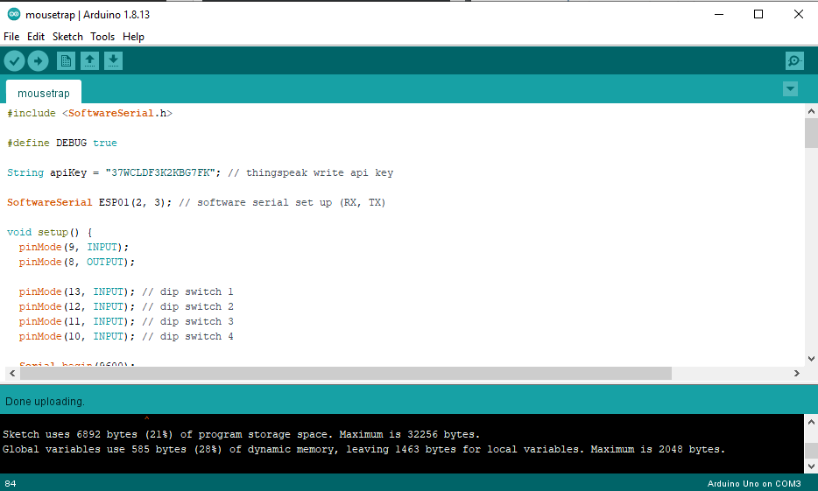

Launch Serial Monitor from the Tools dropdown menu.

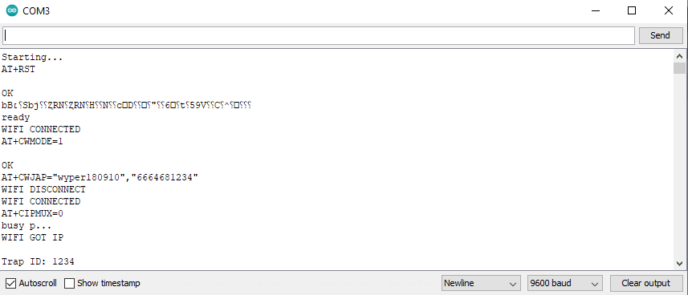

As shown above, the values of the PIR sensor and dip switches are constantly being uploaded to Thingspeak.

When the PIR sensor detects the presence of a living being, the LED will turn on and a value of ‘1’ for the PIR sensor will be uploaded to Thingspeak along with the value of the dip switches. 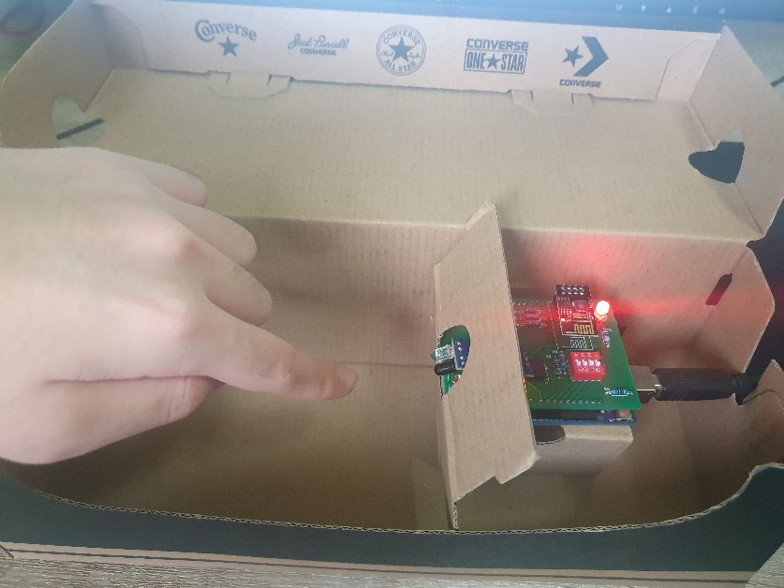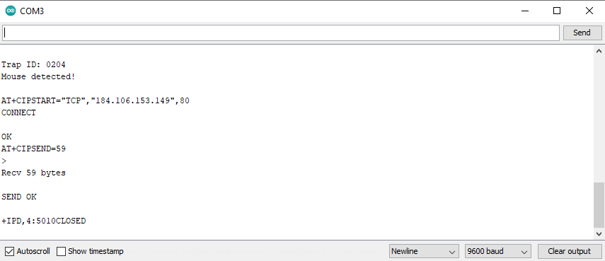

When the PIR sensor doesn’t detect the presence of any living being, the LED will turn off and a value of ‘0’ for the PIR sensor will be uploaded to Thingspeak along with the value of the dip switches.

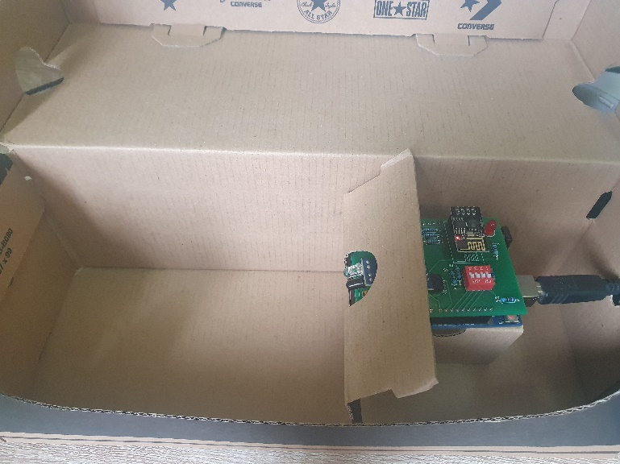

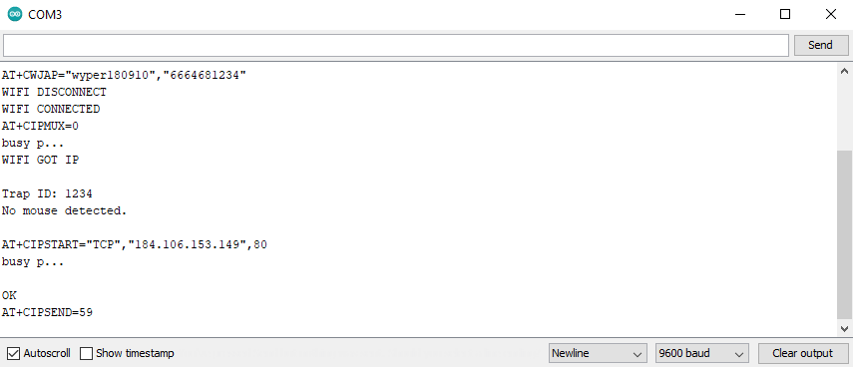

The ID of the trap can also be modified by turning on and off the individual dip switches. The changes will be reflected on Thingspeak. Field 1 displays the PIR sensor value while Field 2 displays the dip switches value.

